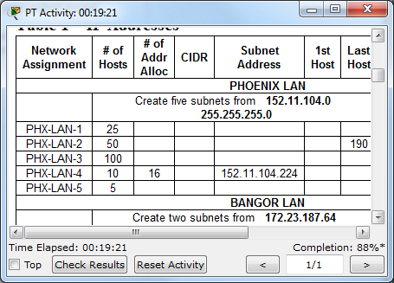

I forgot to enter my name in the first box, so I’ll just put it here and in all filenames.
Alex Kolar

